Ideation Phase

Empathize & Discover
Project Title | DarshanEase: A Smart Temple Darshan Booking System Using MERN Stack
Team ID | ALITS-CSD-2026-DarshanEase
Team Members | Salapala Tharun Kumar Reddy (Team Leader); A. Goutham; M. Siva Prasad; M. Akhila; K. Hemalatha
College | Anantha Lakshmi Institute of Technology and Sciences (ALITS)
Academic Year | 2026

Empathy Map Canvas: Primary persona — Devotee planning a temple visit
The map below captures what our target user says, thinks, does, and feels, along with their pains and gains, based on the problem statements identified for DarshanEase.
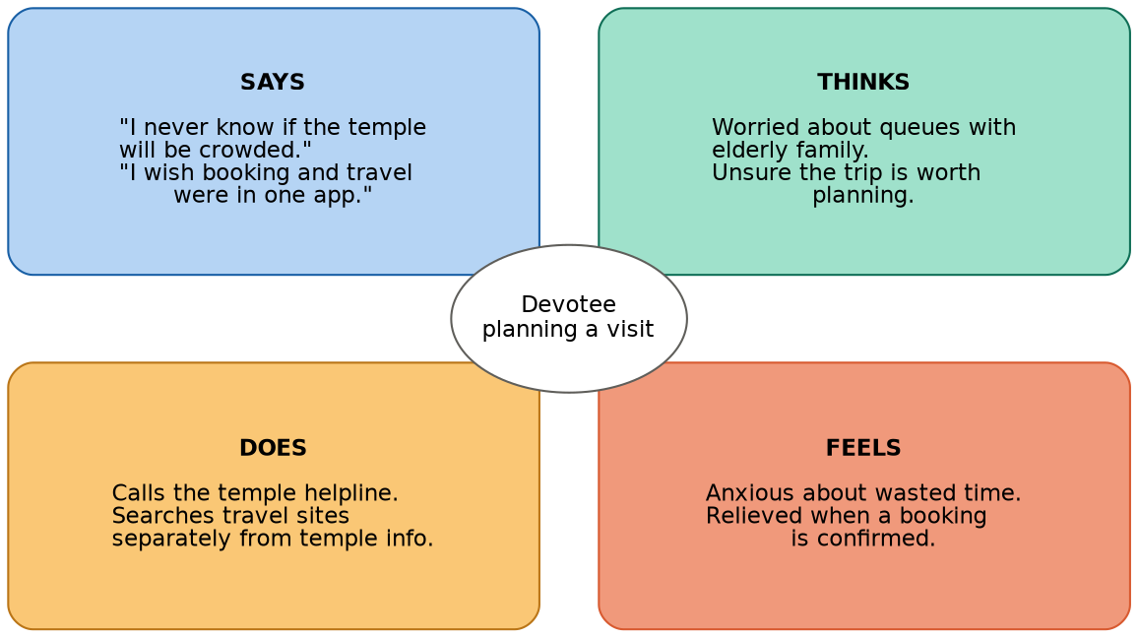
Figure: Empathy map for the devotee persona

Says
- "I never know if the temple will be crowded when I arrive."
- "I wish I could just book my slot and travel tickets from one app."
- "The temple website doesn't tell me the current darshan timings."

Thinks
- Worried about standing in long queues in the heat with elderly family members.
- Unsure whether the trip is worth planning given uncertain slot availability.
- Wants confidence that the booking is confirmed and secure.

Does
- Calls the temple helpline or asks relatives for the latest information.
- Searches multiple travel websites separately from temple websites.
- Arrives early and queues physically to avoid missing darshan.

Feels
- Anxious about wasted travel time and uncertainty.
- Relieved when a booking is confirmed in advance.
- Frustrated by fragmented, non-digital processes.

Pain points
- No single platform integrating booking, travel, and notifications.
- Long physical queues and unpredictable crowd levels.
- Lack of real-time confirmation and reminders.

Gains expected from DarshanEase
- One platform for registration, darshan booking, and journey planning.
- Instant booking confirmation and history tracking.
- Notifications for slot timing and travel updates.

